“Tea Towel” style gowns for infant bereavement
The gown pattern comes in two sizes, the larger size, which is appropriate for babies 3 pounds to newborn and the smaller size, which is appropriate for babies 1-3 pounds. For the larger size, it works out perfectly to cut them from 45” wide fabric as it comes off the bolt, already folded in half. For each 15” segment, you get two gowns. The smaller size isn’t quite as efficient with fabric usage, but you can use the scraps for sleeves. **Please note that if you wish to use snaps to close the smaller size gown, you will need to add an additional ½” of fabric as you cut along each long side to allow enough overlap. Otherwise, you may use ribbon ties.
Before you begin, gather all of your materials. For each gown, you will need:
- Fabric. White quilter’s cotton with a simple pattern, as long as it is not too see through, is a good choice. Polyester fabrics are nice for their anti-wrinkle quality, but are a little more difficult to work with. Eyelet lace fabric is generally too see through. I use the hand test. I put my hand behind the fabric, and if I can just faintly see the outline of it, then it passes. If I can see my ring and other details, it fails. Also, be aware of the texture – some printed patterns are stiff and scratchy. These babies have fragile skin, so choose something that feels soft right off the bolt.
- Lengths of lace and trim for the chest and the bottom. Pictured below are some samples of types that work well. Gathered lace is often too bulky, so look for varieties that are flat and match well with your chosen fabric. Other little embellishments like ribbon roses are a nice touch.
- Ribbons for the neck line, sleeves and back. For all gowns, you will need a 22” length of 5/8” double sided satin ribbon for the collar, as well as two 18” lengths of narrower (1/4-3/8”) ribbon for the sleeve ties. Eyelet ribbon works well because bows tied don’t slip apart as easily. For the tiny size gowns, you can use this same size of ribbon for ties on the back. White is a safe bet, but it is also a nice accent to use blue for boys and pink for girls. If you are making a boy gown, you will also need a short length of 7/8” white satin ribbon (about 8 inches) and a 2” length of 5/8” satin ribbon to make the bow tie.
- Snaps and buttons. 3 sets of clear plastic snaps for each large gown, and 2 sets for the smaller gowns. 2 small blue or white buttons for the boy gowns for decoration on the front.
- Optional: fabric glue to help place the snaps for easier sewing.
- Sewing machine, iron, ironing board.
- Needles and thread for hand stitching details.
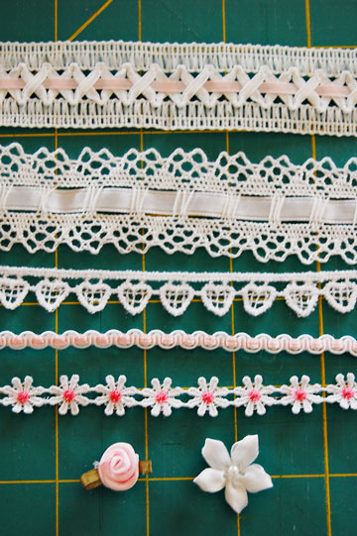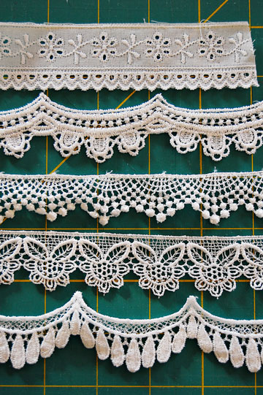
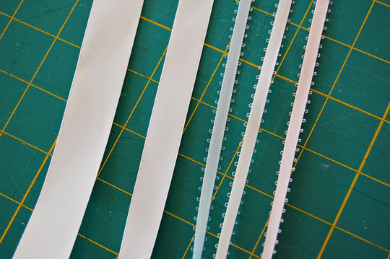
Examples of chest trim, bottom lace, and ribbons.
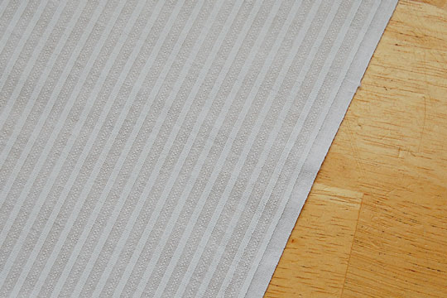
This is an example of fabric that is particularly suited for boy gowns. Gender neutral leaf prints are acceptable as well. Use floral prints only for girl gowns.

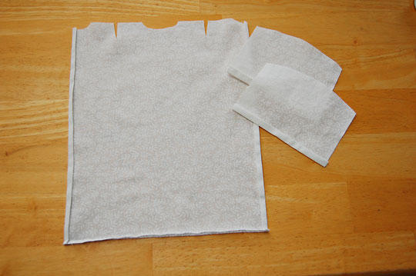
Once you have cut the gown body and sleeves out, the next step is to iron ¼” double rolls along the sides and bottom of the gown (though if it is a girl gown and the bottom is on a selvege, you may skip that edge since you will be sewing lace over it. Do a double roll along the flat edge of the sleeve as well, making sure that the front side of the fabric is facing down. Make sure especially with the smaller size gown that you make these rolls small and consistent in width.

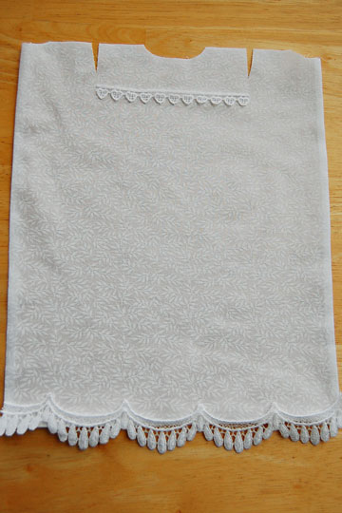
Once you have ironed the gown, lay out your trim and measure it to fit. The chest trim should come to just between the two sleeve cuts, and will be sewn about 2 inches down from the bottom of the neck opening.

Next, sew the rolled seam of the sleeves across on each sleeve, then sew a gather stitch along the curved edge from about an inch in on either side, leaving your threads long.

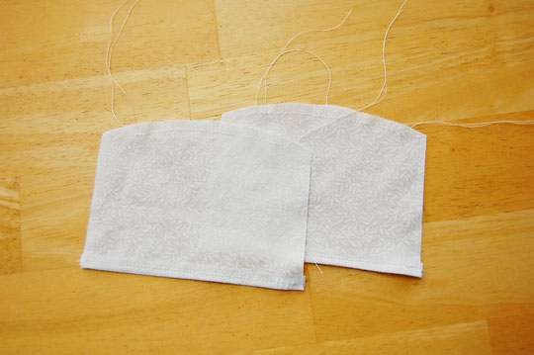

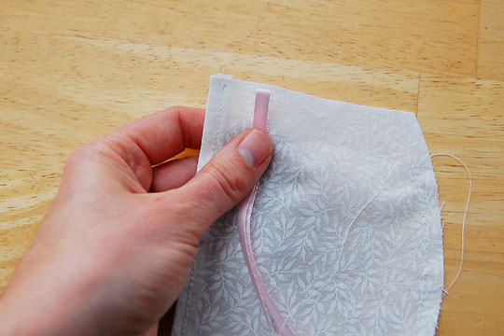
Fold your sleeve ribbon in half and place it on the front side of the fabric, about ¾” to an inch from the sewn end of the sleeve.
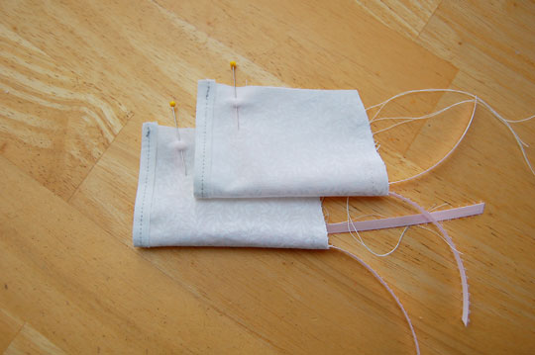
Fold the sleeve over and match edges so that the front side of the fabric is inside, and pin the ribbon in place.
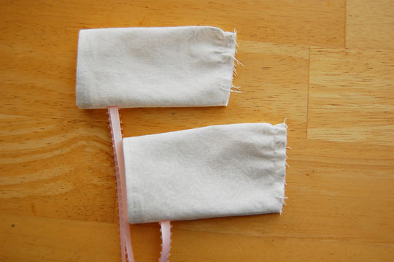
Sew the straight seam, then flip the sleeves right side out. Tug at the gather threads so that they’re just lightly gathered, making sure that both sleeves match. It is better for the sleeves to be a little on the bigger side rather than tightly gathered to facilitate easing fragile arms in. The ribbons at the bottom will tie it all in nicely and make it a more customized fit.
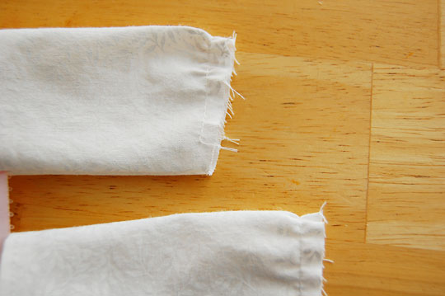
Once you are satisfied that they are even, tie the gather threads off and trim them.
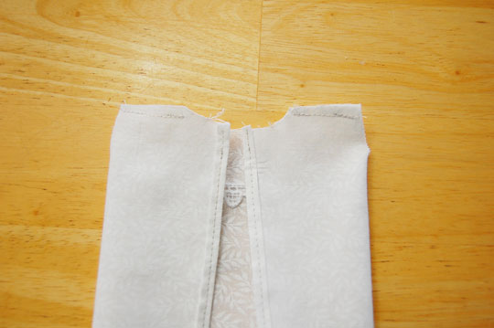
Lay the gown down face up and fold the sides over until the sleeves slits are open on the sides. Sew across the top to bring the tops of the shoulders together.
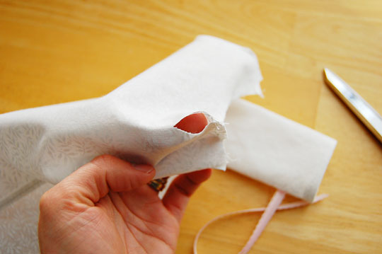
Notice that the sleeve hole is VERY SMALL. We’re going to fix that – don’t panic!
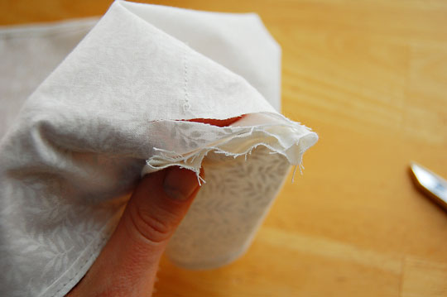
Hold your sleeve up next to the hole and trim the hole to fit the length of the sleeve opening.
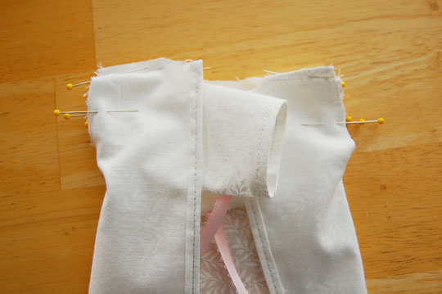
With the gown still inside out, but the sleeves right side out, pin them in place as shown in the picture.
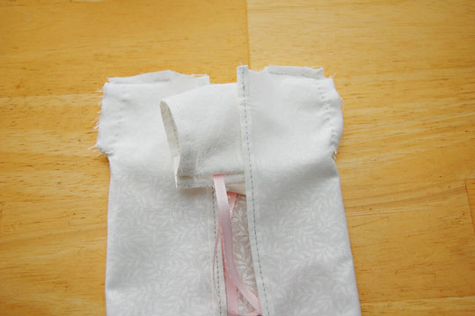
The smaller size sleeves must be stitched in by hand, but the larger sleeves may be carefully machine sewn. Pay extra attention to the bottom of the sleeve hole slit and sew back over it if necessary to make sure that the sleeve is entirely solidly captured.
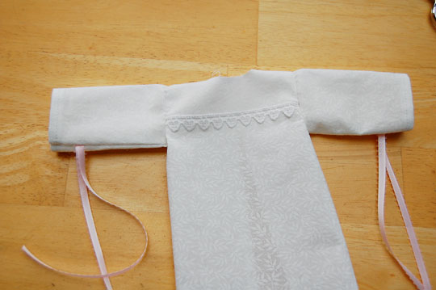
Turn the gown right side out and admire your progress ☺.
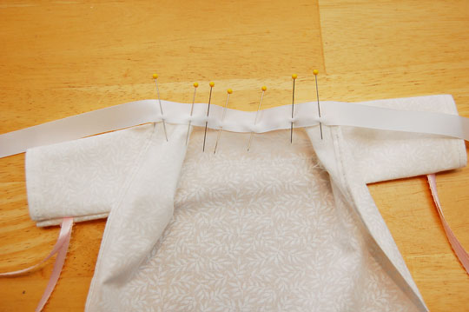
Find the middle of your 22” long 5/8” satin ribbon, and pin it to the inside of the collar. Allow the dress fabric to extend about halfway up the ribbon. Using several pins to accommodate the curves, pin the ribbon the rest of the length of the collar.
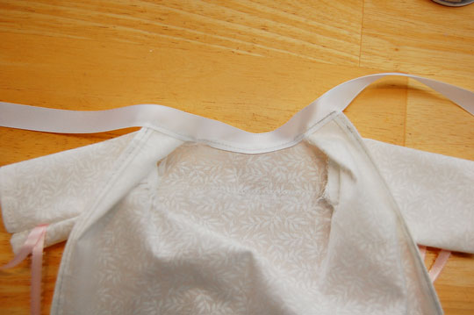
Sew the ribbon down, remove the pins, and flip the gown over to the front side.
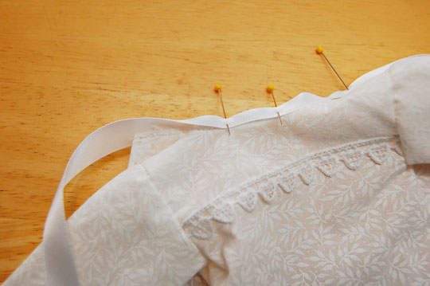
Fold the ribbon over in half to cover up the rough edge and pin it the same way you did the back side. Sew it down, staying as close to the edge as you can but making sure to stay on the ribbon.
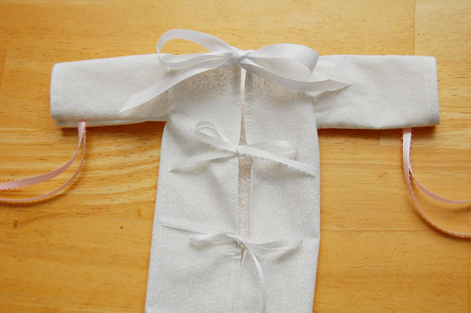
If this is the tiny size gown and you will be doing ribbon ties for closure, sew two sets of 7-8” long ribbons at 3” intervals from the neckline.
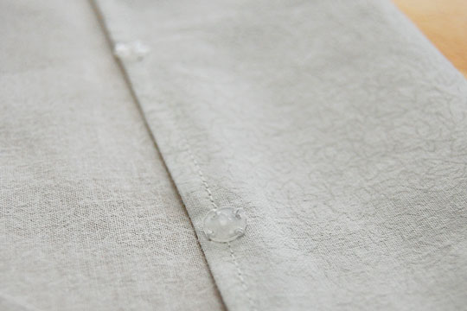
For snap closures, dab a tiny amount of fabric glue on the snaps, making sure that the pointy half of the snap is facing away from the baby, and line up three sets of snaps, also at 2 ½-3” intervals. The snaps will not go the whole length of the gown in the back, but should extend about 2/3 of the way down.
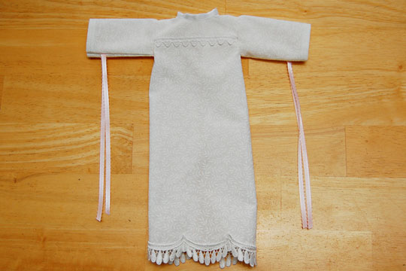
Singe the ends of the ribbons or use fray stop to finish them nicely, press it, and add any little embellishments you desire such as ribbon roses or a bow tie.
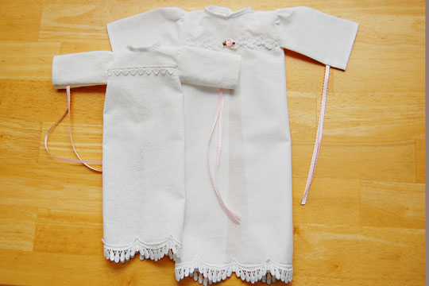
Here is a size comparison of the two patterns.
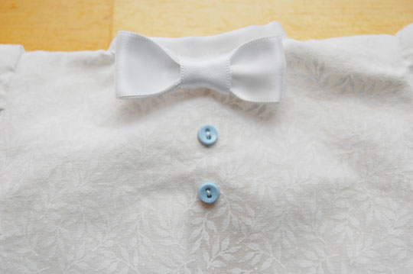
Here is the completed boy gown detail – a bow tie and two buttons.
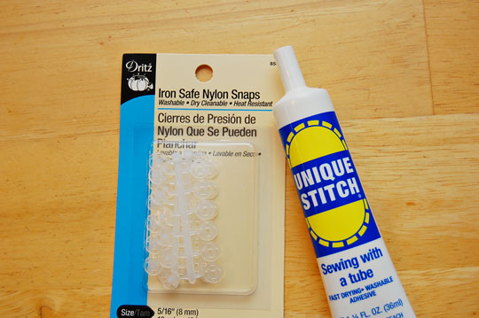
Iron safe snaps are best, and Dritz brand seem to be the most consistent quality. Cheaper ones sometimes don’t stay snapped together the way they should.
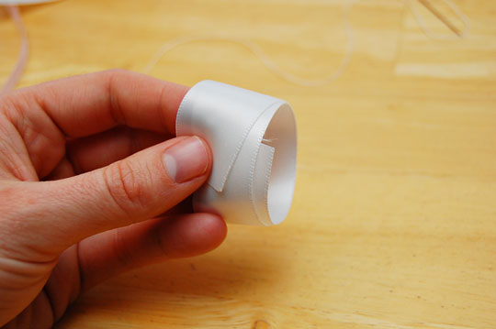
Making the boy bow ties is simple. A double loop of 7/8” ribbon adds an extra measure of stiffness to help the bow tie hold it’s shape. Overlap the ends by a half inch to give you room to stitch the middle gather stitch.

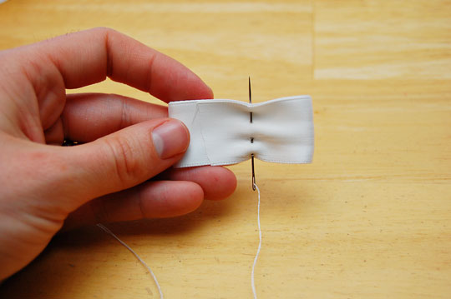
Run an over under over under stitch slightly off center.
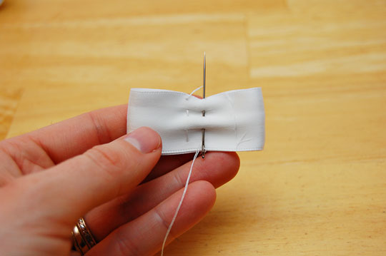
Then repeat at the same intervals going the opposite direction.
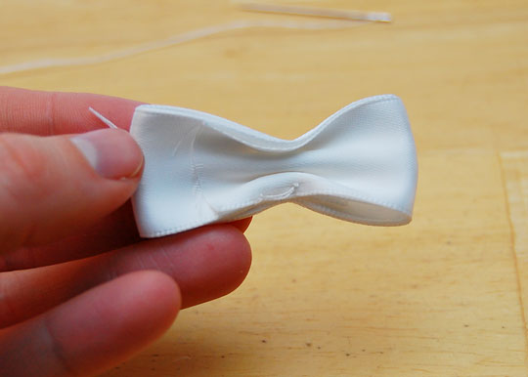
Give the thread a good tug and tie the thread off, leaving the bow gathered.
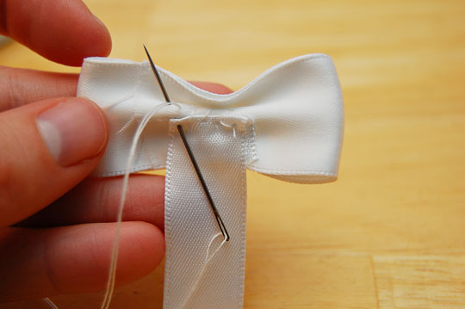
Fold over the end of 2- 2 ½” long 5/8” wide ribbon and stitch it securely down to the back side of the bow.
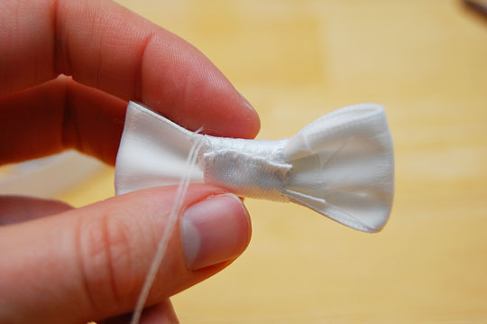
Wrap the ribbon around the front side, fold a little tab over, and stitch it closed securely. Tie it off.
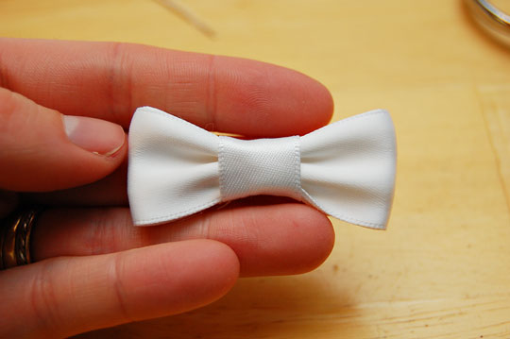
Tug and straighten the tie and voila! A cute little tie!

